https://www.jdoodle.com/embed/v0/5U2E
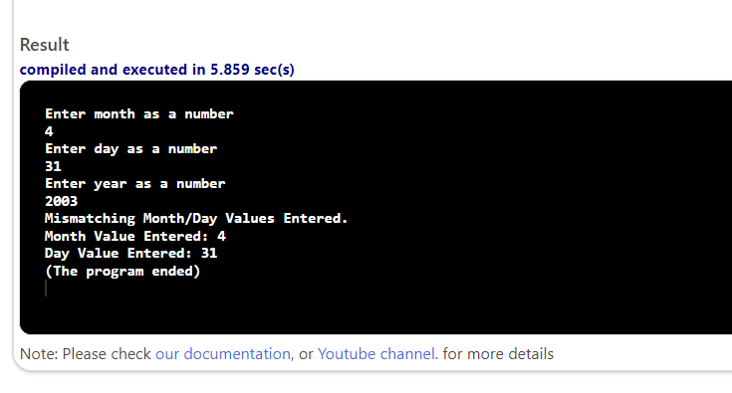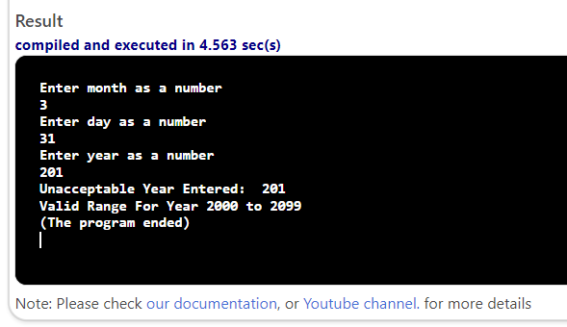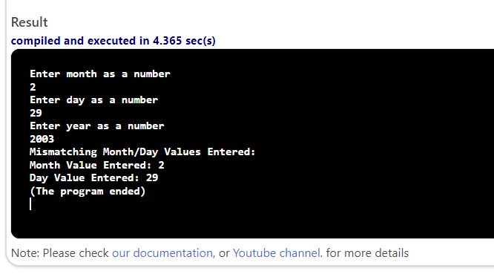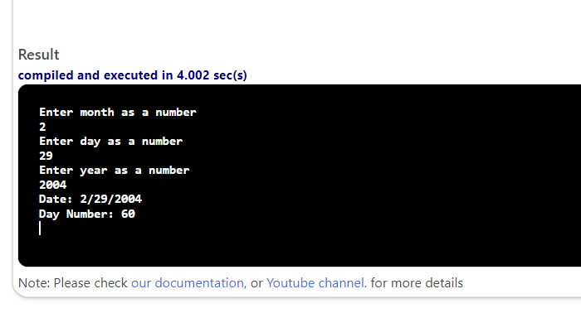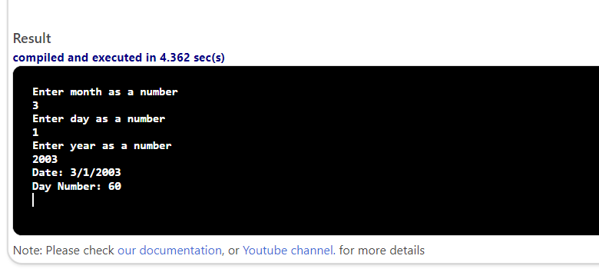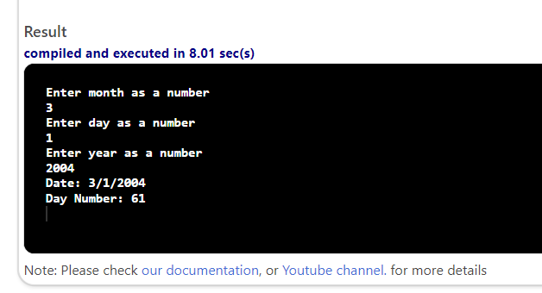

#include <iostream>

using namespace std;

int main()
{
int day, month, year, dayNum;
cout << "Enter month as a number" << endl;
cin >> month;
cout << "Enter day as a number" << endl;
cin >> day;
cout << "Enter year as a number" << endl;
cin >> year;
bool leapyear = false;
if ((year % 4) == 0) {
if ((year % 100) == 0) {
if ((year % 400) == 0) {
leapyear = true;
}
} else {
leapyear = true;
}
}
if ( year < 2000 || year > 2099 )
{
cout << "Unacceptable Year Entered: "<< year << endl;
cout << "Valid Range For Year 2000 to 2099" << endl;
cout << "(The program ended)" << endl;
return 0;
}
if ( month < 1 || month > 12 )
{
cout << "Invalid Month Entered: "<< month << endl;
return 0;
}

if ( ( day < 1 ) || ( day > 31 ) )
{
cout << "Invalid Day Entered: "<< day << endl;
return 0;
}
if ( ( month == 4 || month == 6 || month == 9 || month == 11) && ( day > 30 ) )
{
cout << "Mismatching Month/Day Values Entered. " << endl;
cout << "Month Value Entered: "<< month << endl;
cout << "Day Value Entered: " << day << endl;
cout << "(The program ended)" << endl;
return 0;
}
if ( (month == 2) && ( day > 29 ) && ( leapyear ) )
{
cout << "Mismatching Month/Day Values Entered: " << endl;
cout << "Month Value Entered: " << month << endl;
cout << "Day Value Entered: " << day << endl;
cout << "(The program ended)" << endl;
return 0;
}
if ( (month == 2) && ( day > 28 ) && ( ! leapyear ) )
{
cout << "Mismatching Month/Day Values Entered: " << endl;
cout << "Month Value Entered: "<< month << endl;
cout << "Day Value Entered: "<< day << endl;
cout << "(The program ended)" << endl;
return 0;
}
switch (month) {
case 1:
dayNum = day;
break;

case 2:
dayNum = day + 31;
break;

case 3:
dayNum = day + 31 + (leapyear ? 29 : 28);
break;

case 4:
dayNum = day + 31 + (leapyear ? 29 : 28) + 31;
break;

case 5:
dayNum = day + 31 + (leapyear ? 29 : 28) + 31 + 30;
break;

case 6:
dayNum = day + 31 + (leapyear ? 29 : 28) + 31+ 30 + 31;
break;

case 7:
dayNum = day + 31 + (leapyear ? 29 : 28) + 31+ 30 + 31 + 30;
break;

case 8:
dayNum = day + 31 + (leapyear ? 29 : 28) + 31+ 30 + 31 + 30 + 31;
break;

case 9:
dayNum = day + 31 + (leapyear ? 29 : 28) + 31+ 30 + 31 + 30 + 31 + 31;
break;

case 10:
dayNum = day + 31 + (leapyear ? 29 : 28) + 31+ 30 + 31 + 30 + 31 + 31 + 30;
break;

case 11:
dayNum = day + 31 + (leapyear ? 29 : 28) + 31+ 30 + 31 + 30 + 31 + 31 + 30 + 31;
break;

case 12:
dayNum = day + 31 + (leapyear ? 29 : 28) + 31+ 30 + 31 + 30 + 31 + 31 + 30 + 31 + 30;
break;

case 13:
dayNum = day + 31 + (leapyear ? 29 : 28) + 31+ 30 + 31 + 30 + 31 + 31 + 30 + 31 + 30 + 31;
break;

default:
cout << "Invalid month entered." << endl;
break;
}
cout << "Date: " <<month<<"/"<<day<<"/"<<year <<endl;
cout<<"Day Number: "<<dayNum<<endl;
return 0;
}

